

**TPx Channel Partners President's Club 2019**

**Four Seasons Resort – Jackson Hole, WY**

**March 6 & 7, 2020**

**HOSTED INDIVIDUAL ACTIVITIES**

As a TPx Channel Partner Presidents Club Winner, your program includes hosting you and your guest on two activities as offered in the descriptions below. Additional activities can be reserved for you but those costs would be your responsibility. Please note that you can select your activities on the registration page and once confirmed, they cannot be changed or cancelled.

*For additional non-hosted activities and inquiries please contact [tracyw@corporateplanners.com](mailto:tracyw@corporateplanners.com) for more information and costs on own.

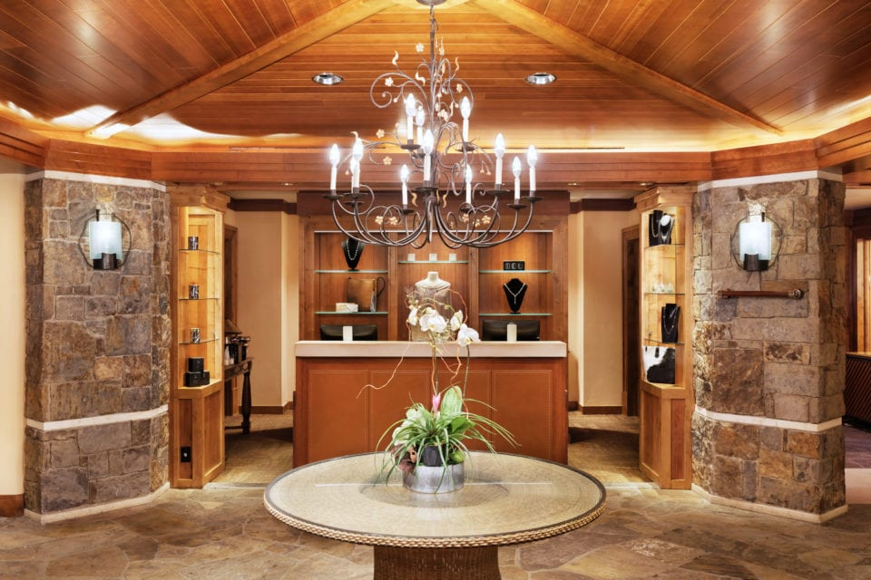

**Spa at the Four Seasons Resort Jackson hole**

* The Spa at Four Seasons Resort Jackson Hole is among the top 100 resort spas in the US, offering a full range of luxurious treatments, massages and more. The Spa accommodations include a sauna, steam room, hot and cold plunge baths, and couple treatment rooms. Additional specialty rooms include rooms, manicure/pedicure stations, and a hair and makeup salon. Bottled water and robes accompany the experience while you also enjoy the baths, relaxation lounges with teas and healthy snacks. A credit of $175.00 will be applied to your spa treatment. All additional costs incurred will be applied to your portfolio.
* Friday March 6th or Saturday Mach 7th
* Activity Time: Approx. 50 minutes
* What to wear: comfortable relaxed clothing

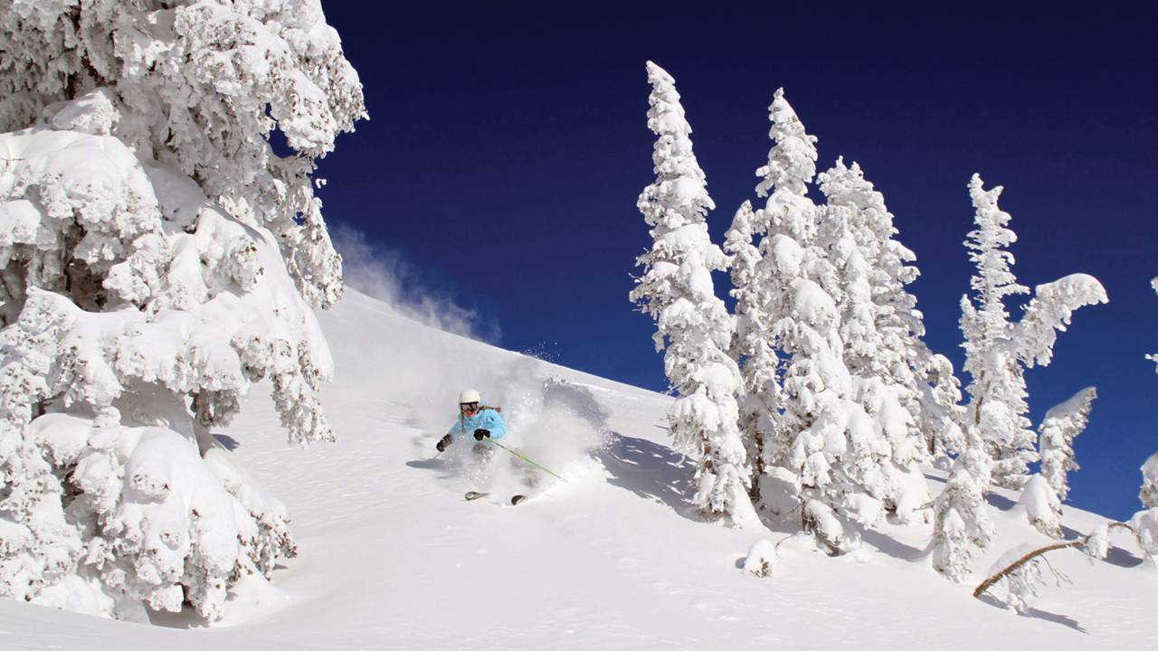

**Downhill Skiing and Snowboarding**

Jackson Hole Mountain Resort which is located slope-side at the Four Seasons, allowing for easy ski-in/ski-out access to the greatest snow on earth. Jackson Hole Wyoming is an exceptional ski resort due to the snow, the amazing steep and challenging terrain, the backcountry, the village, and the lift infrastructure.

Package includes: All-day Lift tickets, Ski/Snowboarding equipment rentals, (upgrades or specific needs are on own and can be billed to your room charge)

* Friday March 6th or Saturday Mach 7th
* Activity Time: 9:00 AM to 4:00 PM
* What to Wear: Wear your snowsuit, jacket and pants. Goggles, warm waterproof gloves and winter snow boots are highly recommended.

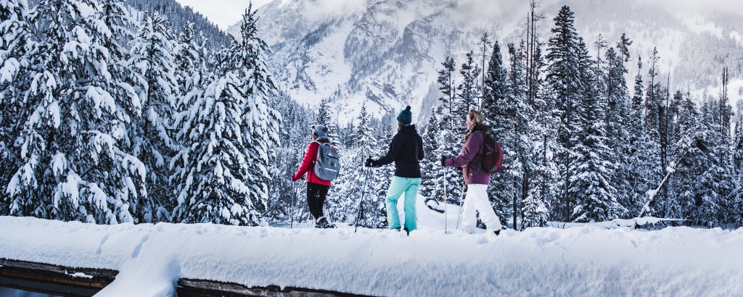

**2 hour Snowshoeing Sampler**

Journey into the heart of winter on snowshoes with a naturalist guide. Follow animal tracks in the snow, examine different aspects of winter ecology and enjoy the outstanding beauty of Jackson Hole as it is blanketed in white. Tours are offered in Grand Teton National Park and in the surrounding National Forest.

* Friday March 6th
* Minimum: 7
* Departure: 9:45am From Hotel lobby in Private Van with bottled waters provided.
* Time: 10:00 AM (experience is approx. 2 hours)
* What to Wear: Wear your snowsuit, jacket or pants that you would if skiing or snowboarding. Goggles, warm waterproof gloves and winter snow boots are highly recommended.

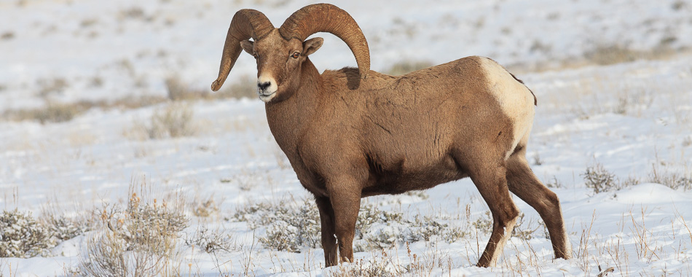

**Jackson Hole Wildlife Safari Tour**

Begin your winter wildlife safari tour with a gourmet coffee, tea or hot chocolate from one of Jackson’s local coffee houses. Then explore the[National Elk Refuge](http://www.fws.gov/refuge/national_elk_refuge/), home to thousands of wintering elk, hundreds of bison, bighorn sheep and an array of bird life. You will then head north along the western boundary of the refuge to [Grand Teton National Park](http://www.nps.gov/grte/index.htm). You will travel along the southern park roads watching for wildlife and stopping frequently for photo-ops. You will see places like antelope flats, the small town of Kelly and have views of several mountain ranges that form the valley of Jackson Hole. Jackson Hole’s wintering wildlife is abundant with opportunities to see bison, elk, deer, moose, fox, coyote, bald eagle, trumpeter swans, and if we’re lucky, wolves.

* Saturday March 7th
* Minimum 4
* Maximum 14
* Departure: From Hotel lobby in Private Van with snacks and bottled waters provided.
* Time: Morning departure time to be finalized(experience is approx. 4 hours)
* What to Wear: Dress as if you were going on a winter road trip, pants, jacket and good boots for outdoors. Extra layers are recommended to stay comfortable in the van. Sunglasses, chapstick and sunscreen

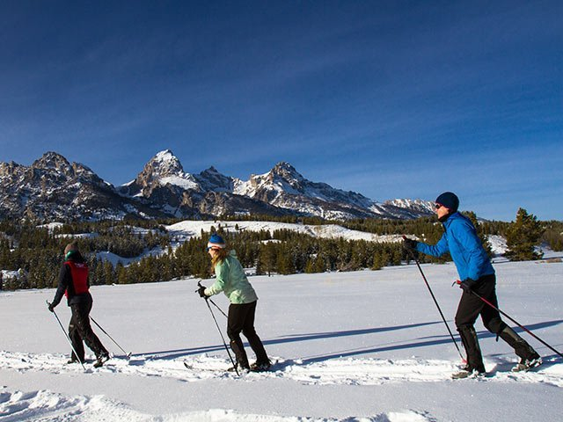

**Cross Country Skiing**

Cross country skiing is a great activity for non-skiers or for those just looking to mix it up a little. With a sloping track spanning 15 kilometers, Shooting Star boasts one of the valley's finest nordic areas with a variety of terrain options. The main track features a large loop around the perimeter of the golf course as well as optional spurs off the main loop. A dog-friendly loop, dubbed Buddy's Trail, encircles the perimeter of the practice facility. The Shooting Star Nordic Track is located on the Teton Village Road, minutes away from Teton Village.as well as optional tracks inside the loop.

* Friday March 6th or Saturday Mach 7th
* Activity Time: 9:00 AM to 5:00 PM
* Departure: From Hotel lobby in a Four Seasons Private Van for a 5minute ride to Shooting Star
* Time: 9:00 AM
* What to Wear: Wear your snowsuit, jacket and pants. Goggles, warm waterproof gloves and winter snow boots are highly recommended.